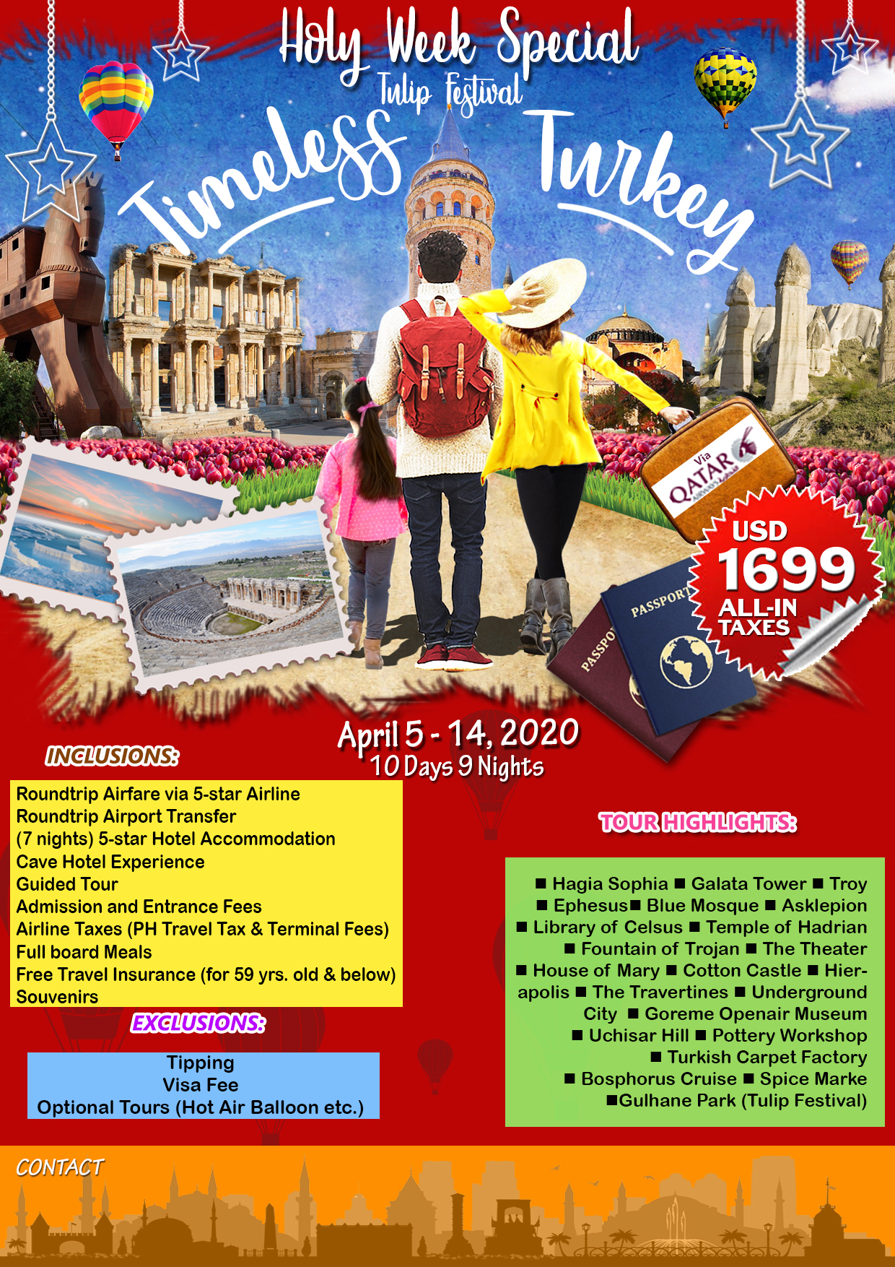

***434 Leon Guerrero St. Ermita, Manila Philippines 1000  
Tel: (02) 7794 7596; (02) 8522 03989  
Mobile: +63 9175252913  
Email: mhtravel9@yahoo.com***