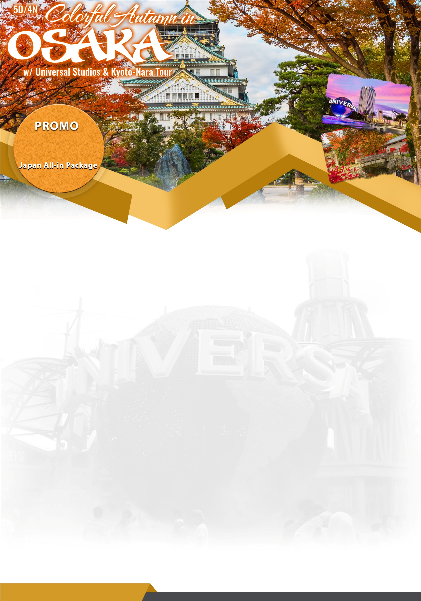

**/person**

**P54,888**

**TRAVEL DATE**

**P54,888/person** 16-20 OCT19 17-21 OCT19 **(Super Peak Autumn)**

**P55,888/person P56,888/person** 13-17 NOV19 21-25NOV19 14-18 NOV19 22-26NOV19

**(All Saints Day Holiday)** 28NOV-02DEC19 **P56,888/person** 02-06NOV19

**FLIGHT DETAILS:**

Manila (MNL) - Osaka (KIX)

Flight No. 5J-82802:55PM-08:10PM

Osaka(KIX) - Manila (MNL)Flight No. 5J-82709:15PM-12:25AM

**INCLUSIONS**

*Roundtrip Airfare via Cebu Pacific *Free 7kgs handcarry baggage *Manila/NAIA Terminal Fee *4 Nights Hotel Accommodation in Hotel WBF Shinsaibashi or 3* similar class *Meals as per Itinerary *Roundtrip Airport transfers (airport-hotel-airport) *Osaka Full Day City Tour *Kyoto-Nara Full Day City tour *Universal Studios Japan with Unlimited ticket *English Speaking Tour guide *All Entrance and Admission Fees as per itinerary *Airline Taxes *FREE! Japan Visa Processing *FREE! Travel Insurance

**EXCLUSIONS**

*Ph Travel Tax P1,620/pax*Tipping to Tour Guide/driver (USD5/pax/day)*Check-in Baggage

**CHILD NO BED: Less P17,000of the adult Twin/triple sharing ratesSINGLE SUPPLEMENT: P12,500**

**ITINERARY**

**DAY 1: MANILA TO OSAKA (--/--/--)Arrival at Osaka Airport, meet tour guide. Transfer to hotel, check in hotel.**

**DAY 2: OSAKA CITY FULL DAY CITY TOUR (Breakfast/Lunch)**After breakfast in hotel, visit Osaka Castle (Photo), Aqualiner/Dotonbori Cruise,Umeda Sky Building Observatory, Umeda District. The rest of the day is free time for leisure. Overnight in Osaka Hotel.

**DAY 3 UNIVERSAL STUDIOS JAPAN (Breakfast)**After breakfast in hotel, proceed to Universal Studios Osaka Japan with unlimited ticket.Overnight in Osaka Hotel.

**DAY 4 KYOTO - NARA FULL DAY CITY(Breakfast/Lunch)** After breakfast in hotel, proceed to Kinkakuji Temple, Nijo Castle, TodaijiTemple/ Nara Deer Park, Nara Nagomikan Overnight in Osaka Hotel

DAY 5 OSAKA - MANILA(Breakfast)After breakfast in Hotel, Free time for leisure and shopping until transfer to Osaka Airport for departure.

**TERMS AND CONDITIONS**

*A Non-refundable P7,000 per person initial downpayment will be charged to reserve slots. *Succeeding 2nd and 3rd month P5,000/pax downpayment is required to guarantee reservation.*All downpayments are non-refundable.*Full payment will be required 1 month prior to the departure dates*Itinerary and meals can be flexibly changed according to local conditions without prior notice*Applicable foreign passportholder surcharge apply.*Itinerary and meals can be flexibly changed according to local conditions without prior notice.*Child no bed 3-10 yrs old, while infant is below 2 yrs old at the date of travel.